Ladies Club Distance Chart

Use the info in this chart to help determine which club you should use during your golf game.

Club | Beginner | Avg | Pro
Woods
1- Driver | 170+ | 220+ | 250+
3 | 160-170 | 200-220 | 220-240
5 | 150-160 | 180-200 | 200-220
Irons
2 | 160-170 | 200-220 | 225-240
3 | 150-160 | 190-200 | 215-225
4 | 140-150 | 175-190 | 200-215
5 | 125-140 | 165-175 | 185-200
6 | 115-125 | 155-165 | 170-185
7 | 105-115 | 145-155 | 155-170
8 | 90-105 | 135-145 | 145-155
9 | 80-90 | 125-135 | 135-145
P-W | 60-80 | 100-125 | 115-135
S-W | 40-60 | 80-100 | 90-115

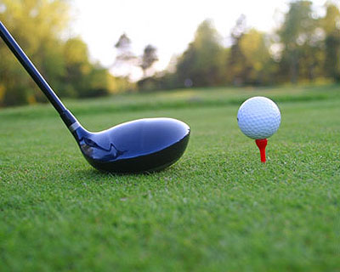

Remember: There are many factors that influence the distances you reach. Some of these factors are:

- Your height
- Your physical condition
- Your swing speed
- Your ability to hit the sweet spot
- The loft angle on each club
- Type of ball you are hitting
- Weather conditions - windy, rainy, dry, humid
- Condition of tees, fairways, bunkers and greens

